# **Image Rotation Using OpenCV**

AARAV RAJ SINGH – CCIS – 2015011 - GEU

A C++ program that takes an image as input and an angle and rotate the image by the given angle then displays the rotated image as an output.

**Technology Used :**

1. Programming Language : C++
2. Tools: OpenCV 4.5.1
3. Soft-wares: Visual Studio 2019 (Community) – 16.8.3
4. Platforms : <https://github.com/opencv/opencv/releases>

**Steps to run the program :-**

1. Download ZIP and extract the file on your local system or clone repository using below command in command prompt :

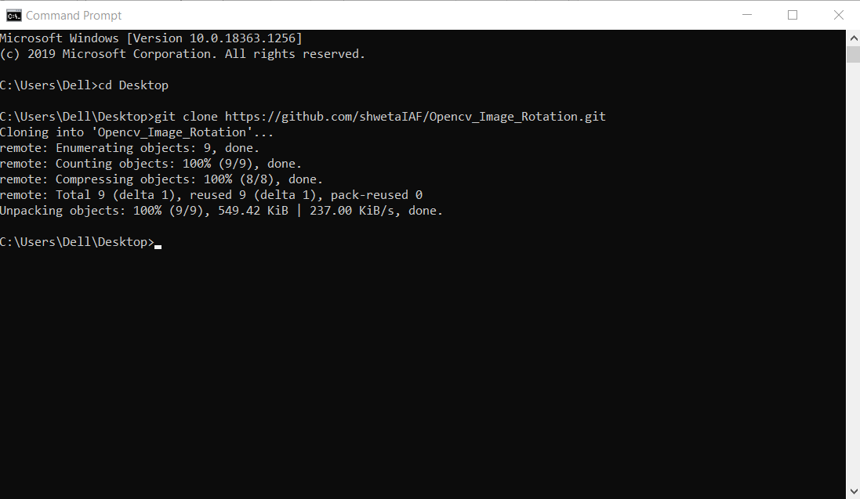

1. Install OpenCV executable file (latest version) in your system.

Download link:- <https://github.com/opencv/opencv/releases>

1. Set up path of OpenCV in environment variables

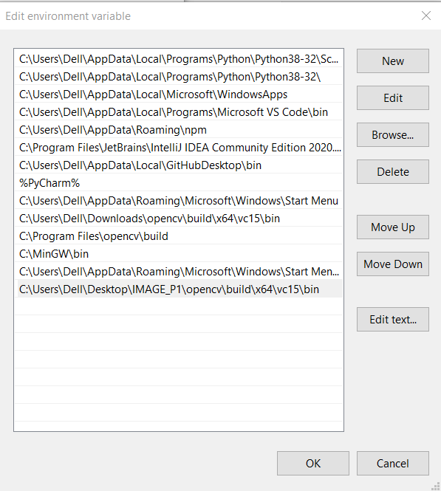

1. Open cloned project in visual studio
2. Now set up the environment for OpenCV in Visual Studio

For Reference :- <https://medium.com/@subwaymatch/opencv-410-with-vs-2019-3d0bc0c81d96>

6)Now you are ready to build your c++ program.

Select x64 debugger before running your program.

7)Run your code using run button provided above and you output can be seen as below.

